Query 1.1: Find the name, genre, and IMDB rating of all the movies.
SQL:
SELECT Movie_Name,Genre, IMDB_Rating FROM movie;
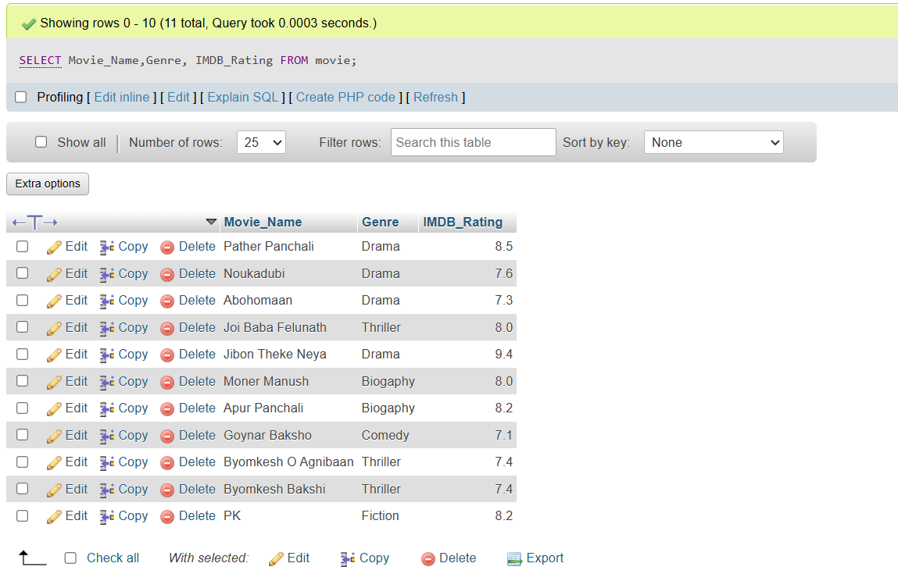

Query 1.2: Display all the distinct movie-genres.
SQL: SELECT DISTINCT Genre FROM movie;
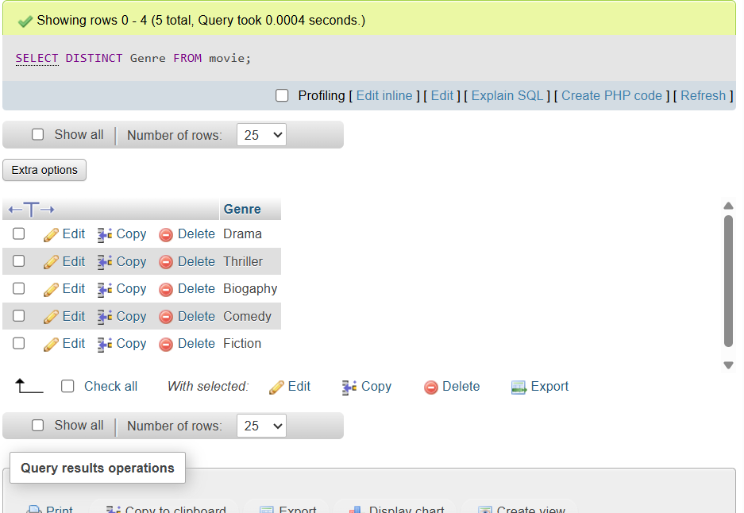

Query 1.3: Find the name and current age of all the actors.
SQL: SELECT Actor_Name, Year(Now())-Birth_Year AS Age FROM actor;
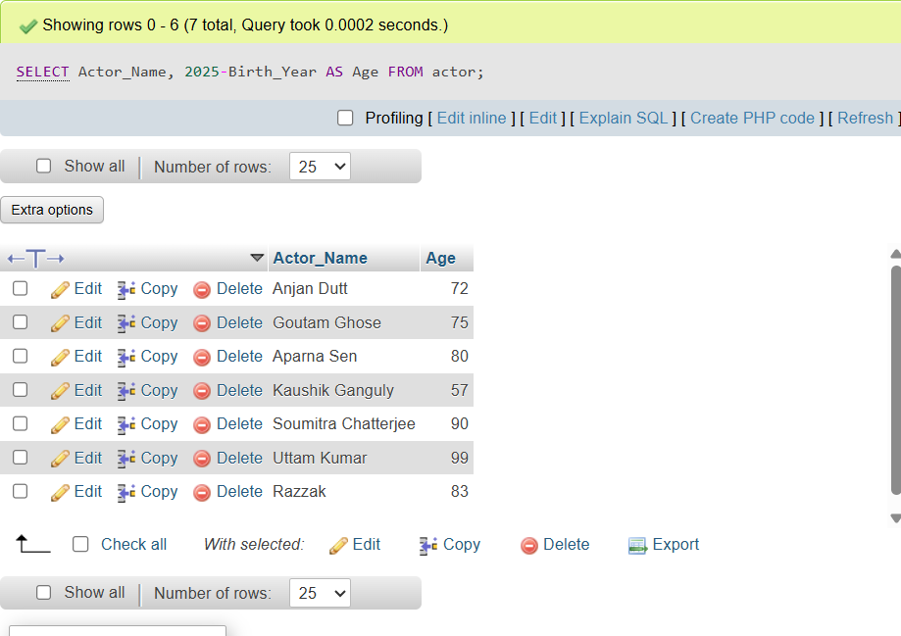

Query 1.4: Find all the movies of the thriller genre with an IMDB rating
greater than or equal to 8.0.
SQL: SELECT Movie_Name,Genre,IMDB_Rating
FROM movie
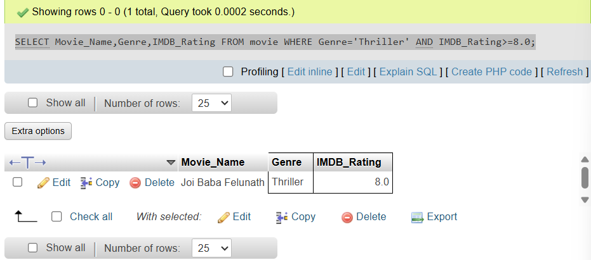
WHERE Genre='Thriller' AND IMDB_Rating>=8.0;

Query 1.5: Find the name, release year, IMDB rating, and the name of the
director of all the movies.
SQL:
SELECT Movie_Name,Year,IMDB_Rating,Director_Name
FROM movie,director
WHERE movie.Director_ID = director.Person_ID;
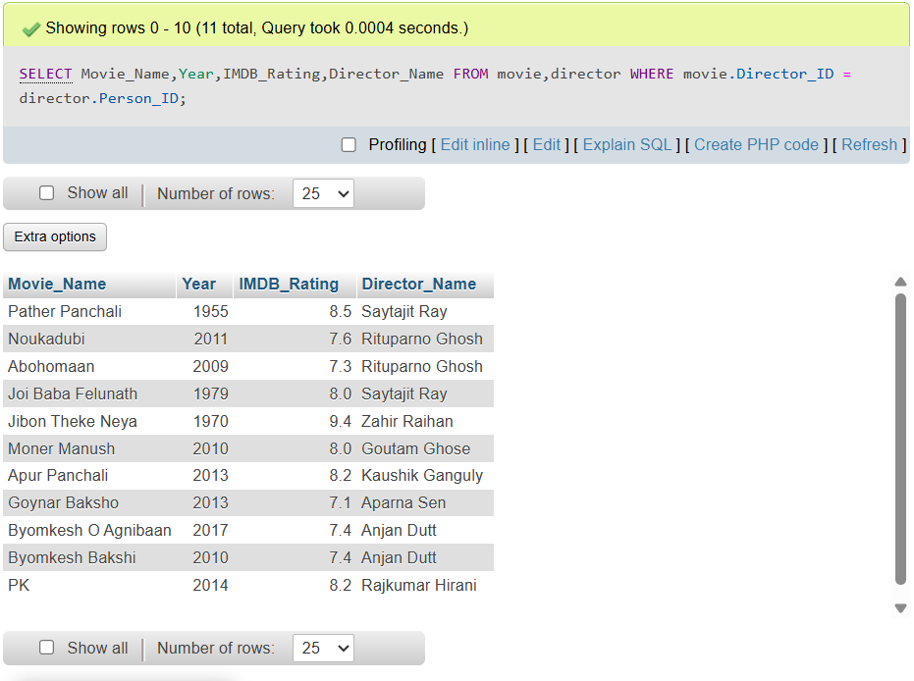

Query 1.6: Find the name and number of awards of those directors whose
name starts with a ‘R’ or a ‘A’.
SELECT Director_Name,No_Of_Awards
FROM director
WHERE Director_Name LIKE 'R%' OR Director_Name LIKE 'A%';
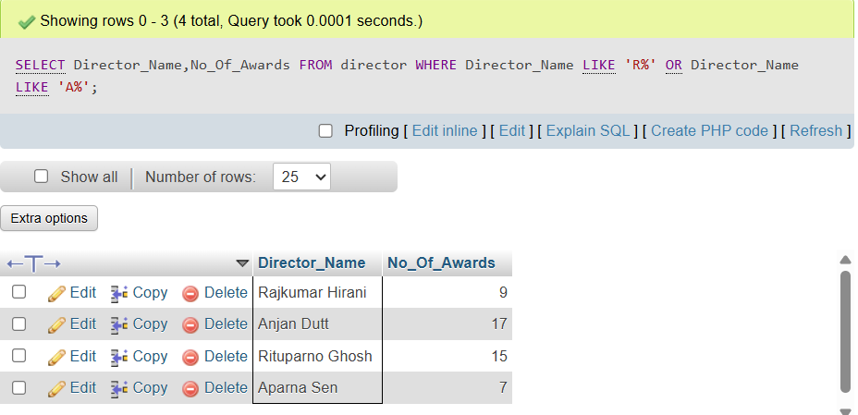
Query 1.7: Find the name and birth year of those directors whose name
contains an ‘a’ as its 2nd last character.
SELECT Director_Name, Birth_Year
FROM director
WHERE Director_Name LIKE '%a_';
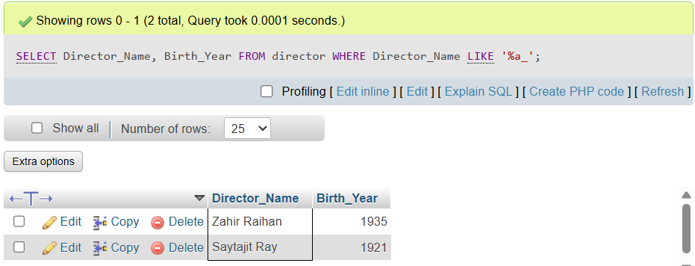

Query 1.8: Find the name, release year, and genre of all the movies which
contain the word ‘Byomkesh’ anywhere in their name.
SELECT Movie_Name, Year, Genre
FROM movie
WHERE Movie_Name LIKE '%byomkesh%';
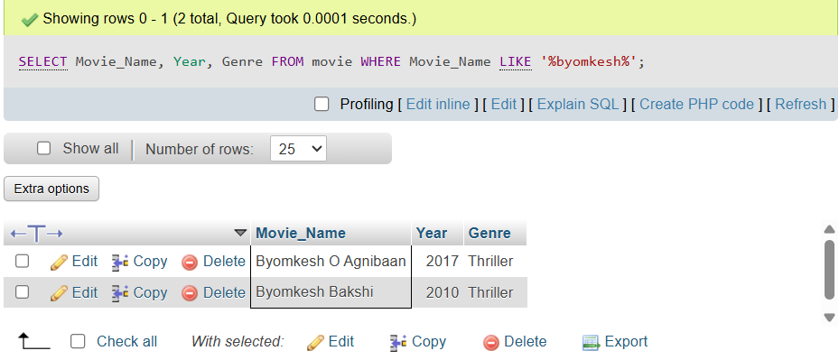
Query 1.9: Find the name and IMDB rating of all the movies whose name
consists of only 2 characters.
SELECT Movie_Name, IMDB_Rating
FROM movie WHERE Movie_Name LIKE '__';
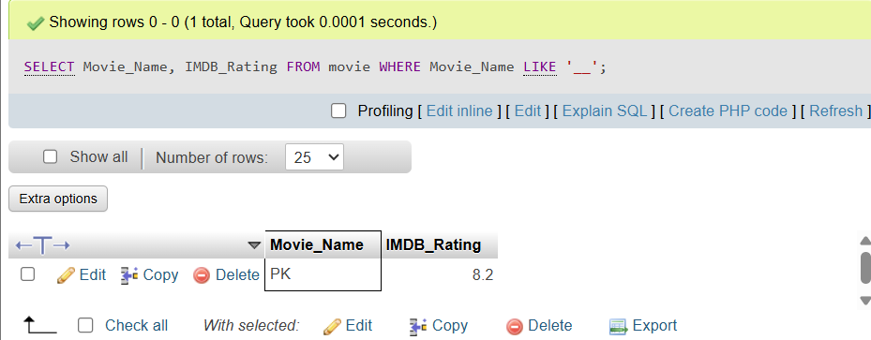

Query 1.10: Find the name and genre of all the movies whose name consists
of at least 3 characters.
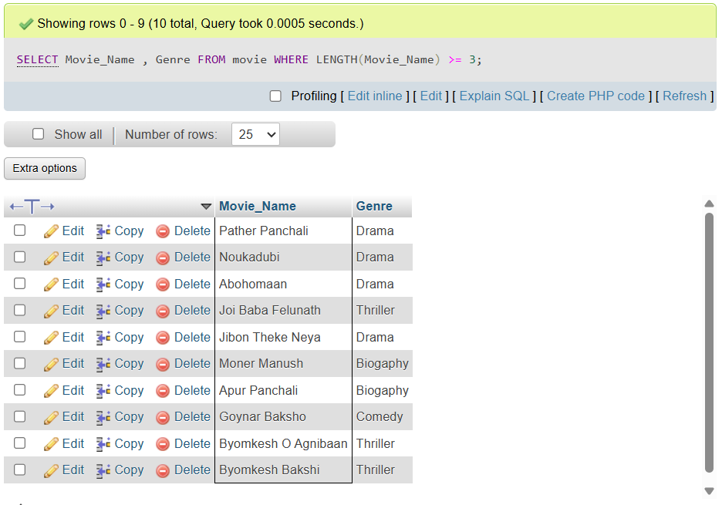
Query 1.Last: Find the name and IMDB rating of all the movies which
contain at most 9 characters in their name.
